Manual Execution Process after Failure for Task Scheduler in Alaska
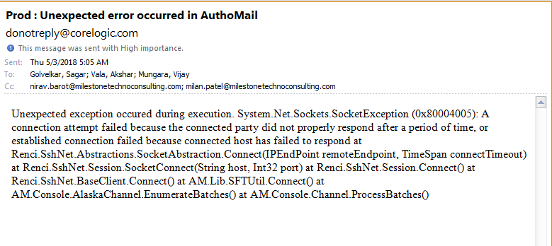
- Check in mail if we receive any mail regarding SFTP Connection Failure error mail just like below

- Then first try to connect Alaska Production SFT site using portable FileZilla from 10.212.24.57 server using your credentials if you have access on 57 otherwise use Brijesh Patel’s credential to manually process batch: Go to File -> Site Manager -> Select “Alaska_Prod” -> Click on connect. If sftp connection made successfully then proceed to Step-3.
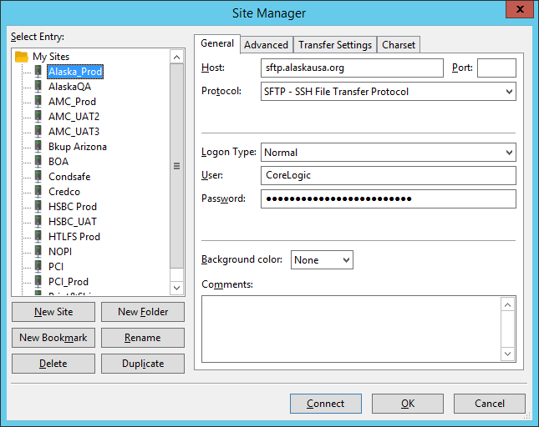

- Open “Task Scheduler” and select below highlighted task and select “Run” from right-hand side “Selected Item” box and check mailbox regarding Download Summary mail in few minutes. If you don’t receive this mail. Then please contact to sgolvelkar@corelogic.com (+91-8460793033).

